SI 650 Information Retrieval Assignment 2 part 1

1. Built Retrieval Function

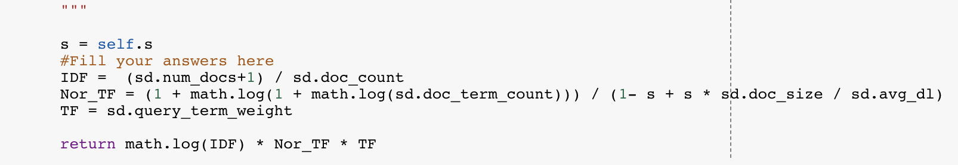Pivoted function:

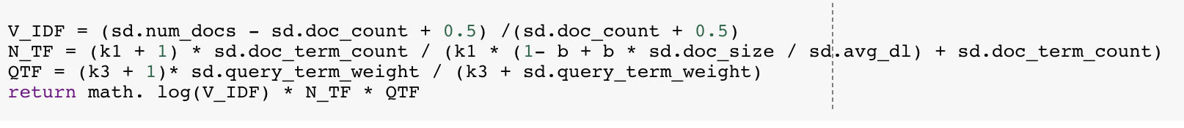BM25 function:

1. 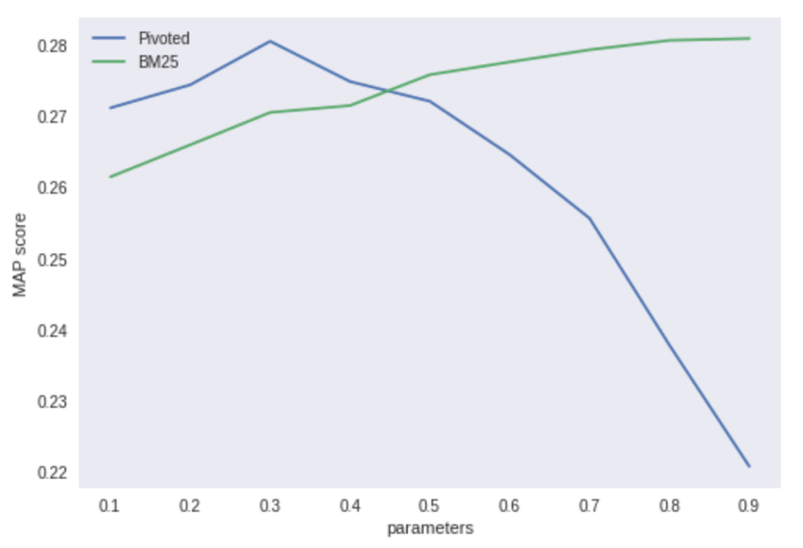Evaluate your Retrieval Function

Pivoted: [0.271180483845591, 0.2744279237181812, 0.2805417429677985, 0.27488304406886577, 0.27211184481732426, 0.2646063060185587, 0.2556696270439405, 0.23785328576891762, 0.22081696949293717]

**The Best parameter is s = 0.3 value = 0**.**2805417429677985**

BM25: [0.261491760735152, 0.265995430371294, 0.27054272369703847, 0.2715105751692196, 0.2758441537423579, 0.27763057856646, 0.2793448148044489, 0.28066853779697154, 0.28092929667443534]

**The best parameter is b = 0.9 value = 0.28092929667443534**

